Government College Women University Faisalabad

Submitted To:
Mam Sadia Saher
Submitted By:
Ayla Mumtaz (23114)
Section:
Morning (C)
Course Title:
Object Oriented Analysis & Design
Department:
Computer Science

1. ATM System – Withdraw Cash:
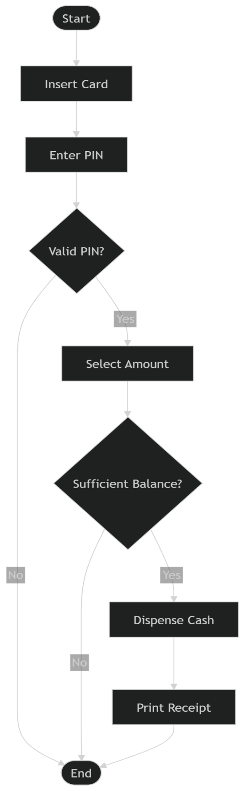
2. Online Shopping – Place Order:
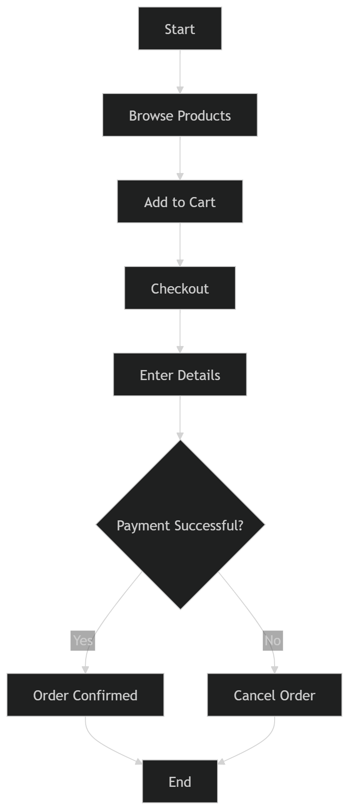
3. Ride Booking System:
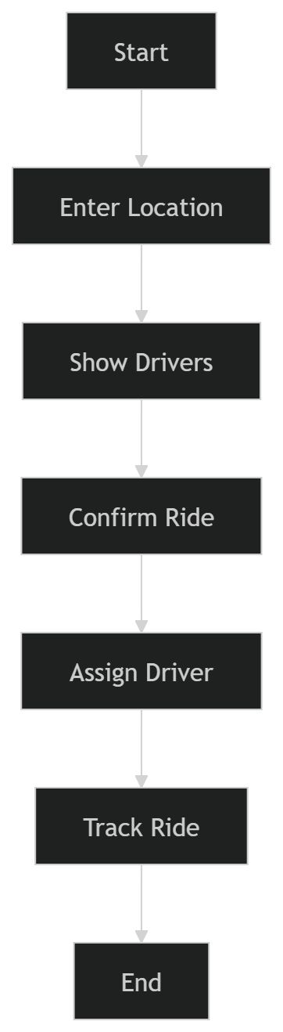
4. Hospital – Book Appointment:
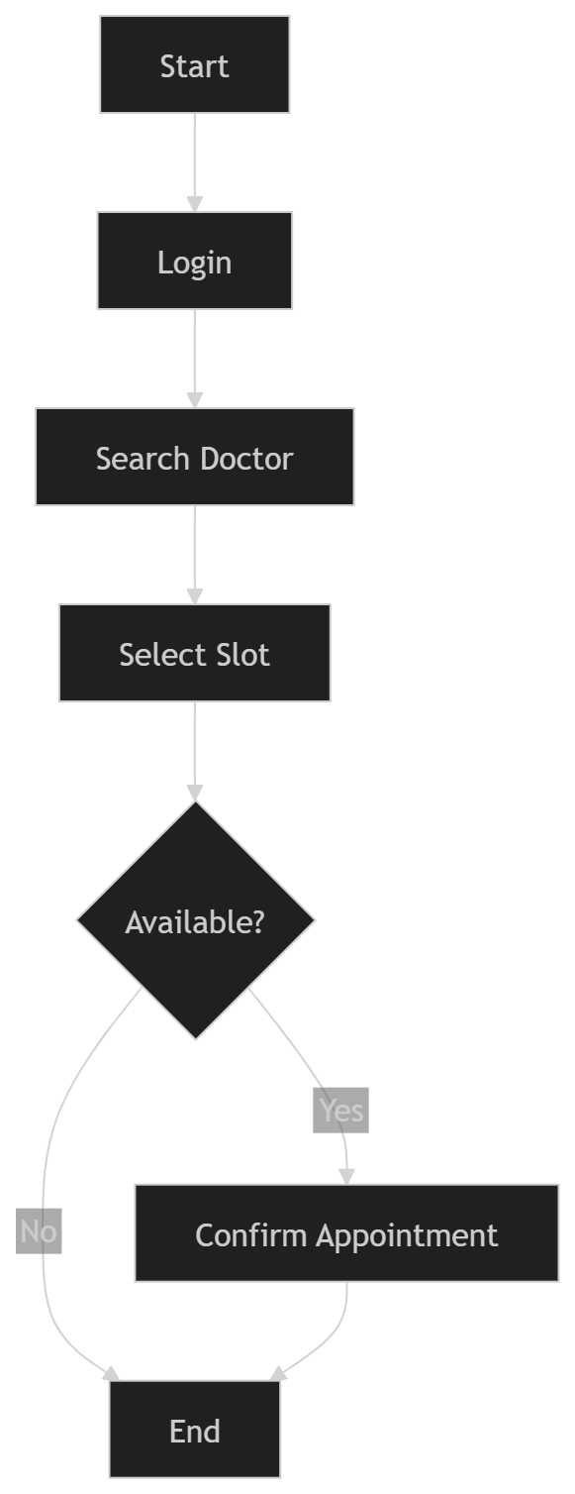
5. Movie Ticket Booking:
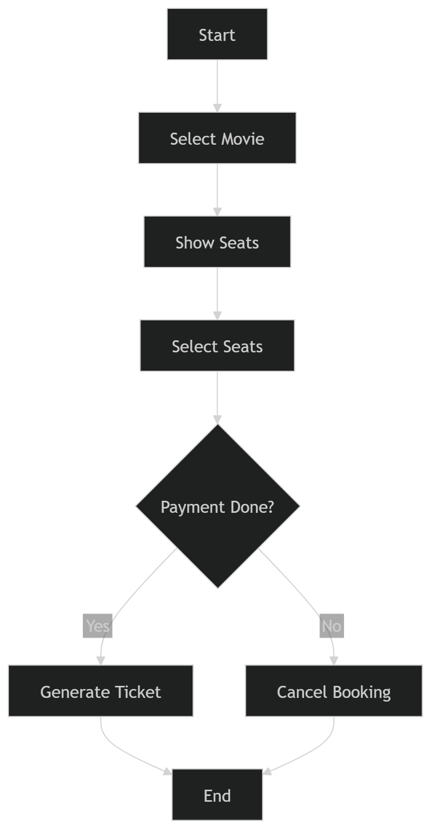
6. Banking – Transfer Money:
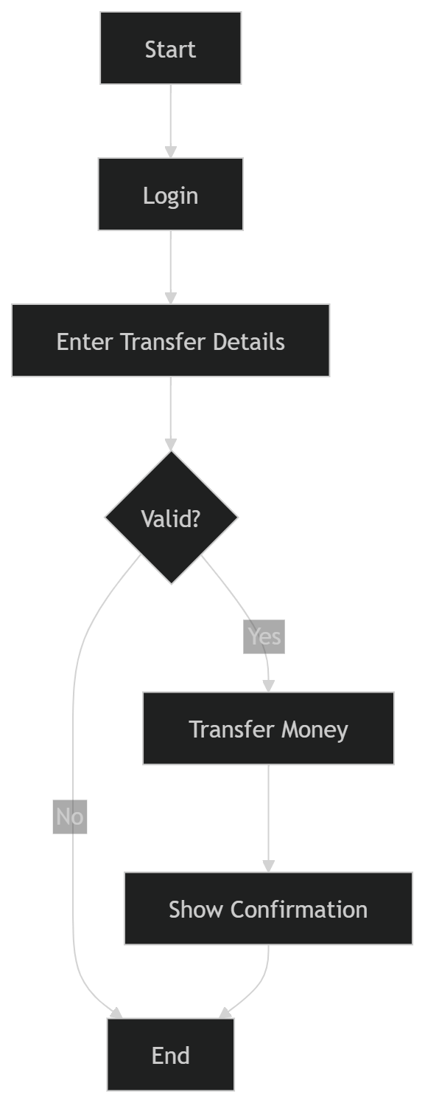
7. Airline Reservation:
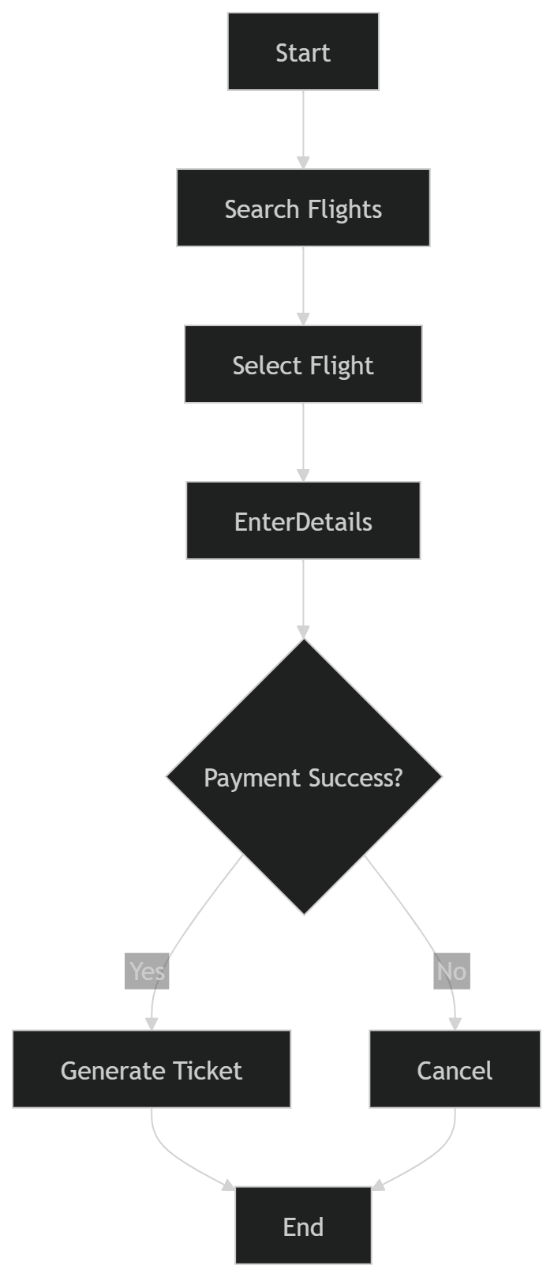
8. Parking System:
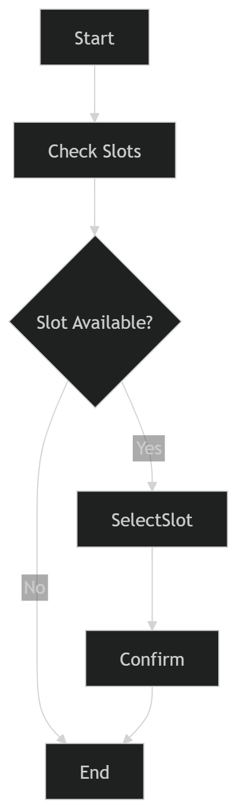
9. Food Delivery System:
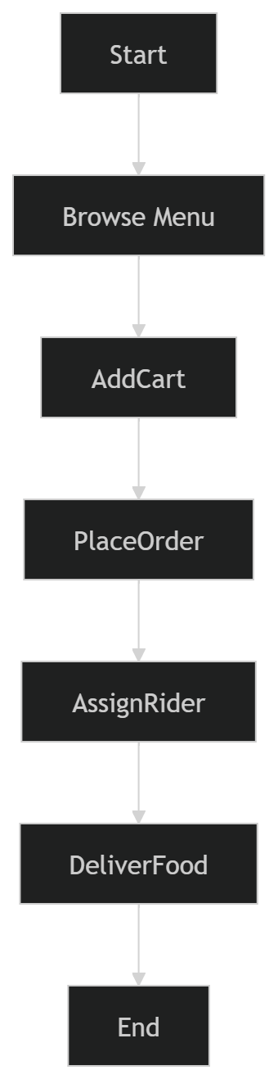
10. Payroll System:
